Kosuke Takahashi

CS370

Tao Xie

CS 370 Homework 2

3-28 & 3-29.

3-36.

Decimal Binary

|  |  |  |  |  |  |  |  |  |  |  |  |  |  |  |
| --- | --- | --- | --- | --- | --- | --- | --- | --- | --- | --- | --- | --- | --- | --- |
| 9 | 8 | 7 | 6 | 5 | 4 | 3 | 2 | 1 | 0 | A3 | A2 | A1 | A0 | V |
| 0 | 0 | 0 | 0 | 0 | 0 | 0 | 0 | 0 | 0 | X | X | X | X | 0 |
| 0 | 0 | 0 | 0 | 0 | 0 | 0 | 0 | 0 | 1 | 0 | 0 | 0 | 0 | 1 |
| 0 | 0 | 0 | 0 | 0 | 0 | 0 | 0 | 1 | X | 0 | 0 | 0 | 1 | 1 |
| 0 | 0 | 0 | 0 | 0 | 0 | 0 | 1 | X | X | 0 | 0 | 1 | 0 | 1 |
| 0 | 0 | 0 | 0 | 0 | 0 | 1 | X | X | X | 0 | 0 | 1 | 1 | 1 |
| 0 | 0 | 0 | 0 | 0 | 1 | X | X | X | X | 0 | 1 | 0 | 0 | 1 |
| 0 | 0 | 0 | 0 | 1 | X | X | X | X | X | 0 | 1 | 0 | 1 | 1 |
| 0 | 0 | 0 | 1 | X | X | X | X | X | X | 0 | 1 | 1 | 0 | 1 |
| 0 | 0 | 1 | X | X | X | X | X | X | X | 0 | 1 | 1 | 1 | 1 |
| 0 | 1 | X | X | X | X | X | X | X | X | 1 | 0 | 0 | 0 | 1 |
| 1 | X | X | X | X | X | X | X | X | X | 1 | 0 | 0 | 1 | 1 |

3-37.

3-52.

1. 11010 – 10001 = 11010 + 01111 = 101001

111

11010

+01111

101001

1. 11110 – 1110 = 11110 + 0001 = 11111

11110

+ 0001

11111

1. 1111110 – 1111110 = 1111110 + 0000001 = 1111111

1111110

+0000001

1111111

1. 101001 – 101 = 101001 + 011 = 101100

11

101001

+ 011

101100

3-53.

1. 11010 – 10001 = 11010 + 01111 = 01001

(-) + (+) = (+) = no overflow

1. 11110 – 1110 = 11110 + 00001 = 11111

(-) + (+) = (-) = no overflow

1. 1111110 – 1111110 = 1111110 + 0000001 = 1111111

(-) + (+) = (-) = no overflow

1. 101001 – 101 = 101001 + 000011 = 101100

(-) + (+) = (-) = no overflow

3-55.

1. 100111 + 111001 = 100000

11111

100111

+111001

100000

1. 001011 + 100110 = 110001

111

001011

+100110

110001

1. 110001 – 010010 = 110001 + 101110 = 011111 (overflow)

110001

+101110

011111

1. 101110 – 110111 = 101110 + 001001 = 110111

1

101110

+001001

110111

4-6.

DA = XA + X’Y’

DB = XB + X’A

Z = X’B

Current State Input Future State Output

|  |  |  |  |  |  |  |
| --- | --- | --- | --- | --- | --- | --- |
| A | B | X | Y | A | B | Z |
| 0 | 0 | 0 | 0 | 0 | 0 | 0 |
| 0 | 0 | 0 | 1 | 0 | 0 | 0 |
| 0 | 0 | 1 | 0 | 0 | 0 | 0 |
| 0 | 0 | 1 | 1 | 1 | 0 | 0 |
| 0 | 1 | 0 | 0 | 0 | 1 | 0 |
| 0 | 1 | 0 | 1 | 0 | 1 | 0 |
| 0 | 1 | 1 | 0 | 0 | 0 | 1 |
| 0 | 1 | 1 | 1 | 1 | 0 | 1 |
| 1 | 0 | 0 | 0 | 1 | 0 | 0 |
| 1 | 0 | 0 | 1 | 1 | 0 | 0 |
| 1 | 0 | 1 | 0 | 0 | 1 | 0 |
| 1 | 0 | 1 | 1 | 1 | 1 | 0 |
| 1 | 1 | 0 | 0 | 1 | 1 | 0 |
| 1 | 1 | 0 | 1 | 1 | 1 | 0 |
| 1 | 1 | 1 | 0 | 0 | 1 | 1 |
| 1 | 1 | 1 | 1 | 1 | 1 | 1 |

4-7.

DA = (BC’ + B’C)X + (BC + B’C’)X’

DB = A

DC = B

Current State Input Future State

|  |  |  |  |  |  |  |
| --- | --- | --- | --- | --- | --- | --- |
| A | B | C | X | A | B | C |
| 0 | 0 | 0 | 0 | 1 | 0 | 0 |
| 0 | 0 | 0 | 1 | 0 | 0 | 0 |
| 0 | 0 | 1 | 0 | 0 | 0 | 0 |
| 0 | 0 | 1 | 1 | 1 | 0 | 0 |
| 0 | 1 | 0 | 0 | 0 | 0 | 1 |
| 0 | 1 | 0 | 1 | 1 | 0 | 1 |
| 0 | 1 | 1 | 0 | 1 | 0 | 1 |
| 0 | 1 | 1 | 1 | 0 | 0 | 1 |
| 1 | 0 | 0 | 0 | 1 | 1 | 0 |
| 1 | 0 | 0 | 1 | 0 | 1 | 0 |
| 1 | 0 | 1 | 0 | 0 | 1 | 0 |
| 1 | 0 | 1 | 1 | 1 | 1 | 0 |
| 1 | 1 | 0 | 0 | 0 | 1 | 1 |
| 1 | 1 | 0 | 1 | 1 | 1 | 1 |
| 1 | 1 | 1 | 0 | 1 | 1 | 1 |
| 1 | 1 | 1 | 1 | 0 | 1 | 1 |

4-12a.

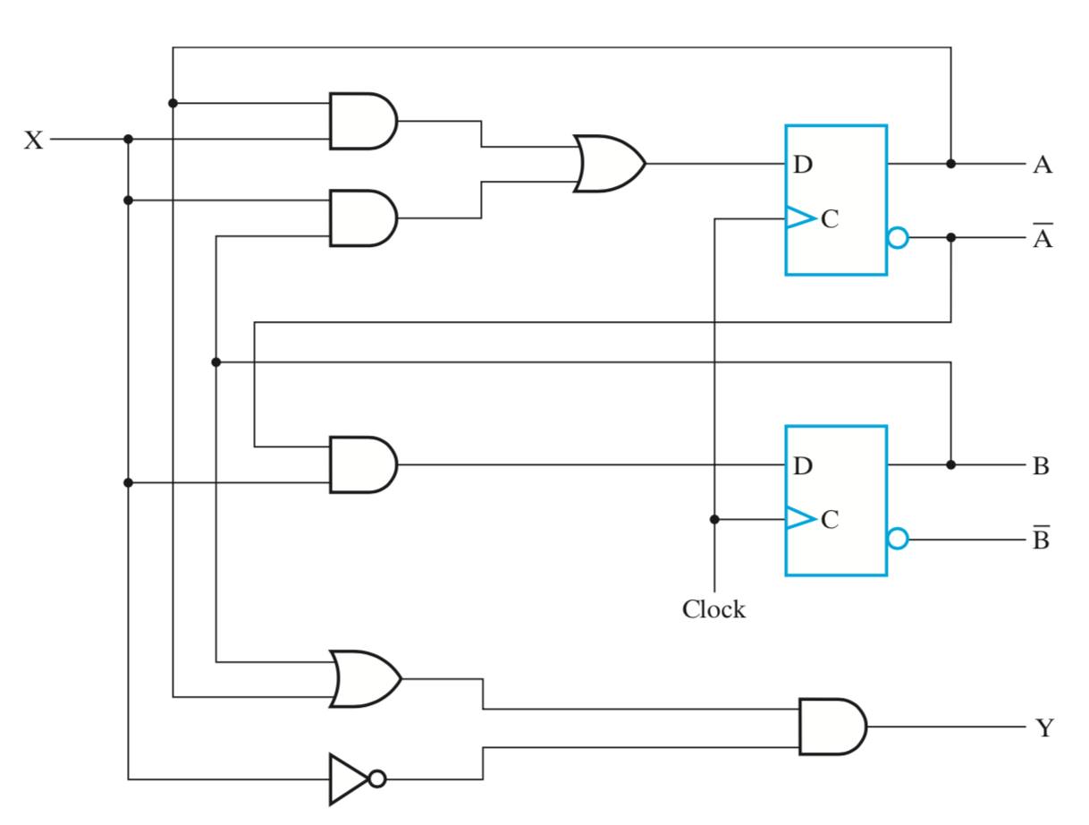

4-17.